WEB APPLICATION ARCHITECTURES

Ajax

Objectives

In this exercise you will investigate Ajax

Reference material
This exercise is based on material from the “Ajax” chapter.

Overview
- In this exercise you will experiment with Ajax using JQuery

Estimated duration
The estimated duration for this lab is ~45 minutes.

Completed solution
There is a completed solution for this lab.

Step by step instructions

Part-1

Investigate Ajax and Web services
In this part you’re not expected to write any code.
First of all, you will run a web server on your own computer. To do this:
- Locate the WebService folder within the starters folder for this chapter
- Double click on the RunMe.bat file to start the server.
This will open up a Command window.
- When finished (but not yet!), press Ctrl-C to end the web server
Next, use a code like the ones on the slides to get customers data from http://localhost:5000/customers and then display the ContactName attribute of each customer
Please use Ajax’s getJSON() method which automatically de-serializes the JSON data and sends an array of objects into the callback function.

Part-2
- Go to https://api.tfl.gov.uk/Line/Mode/tube/Status and have a look at the results. Can you recognise that this URL returns some JSON data?
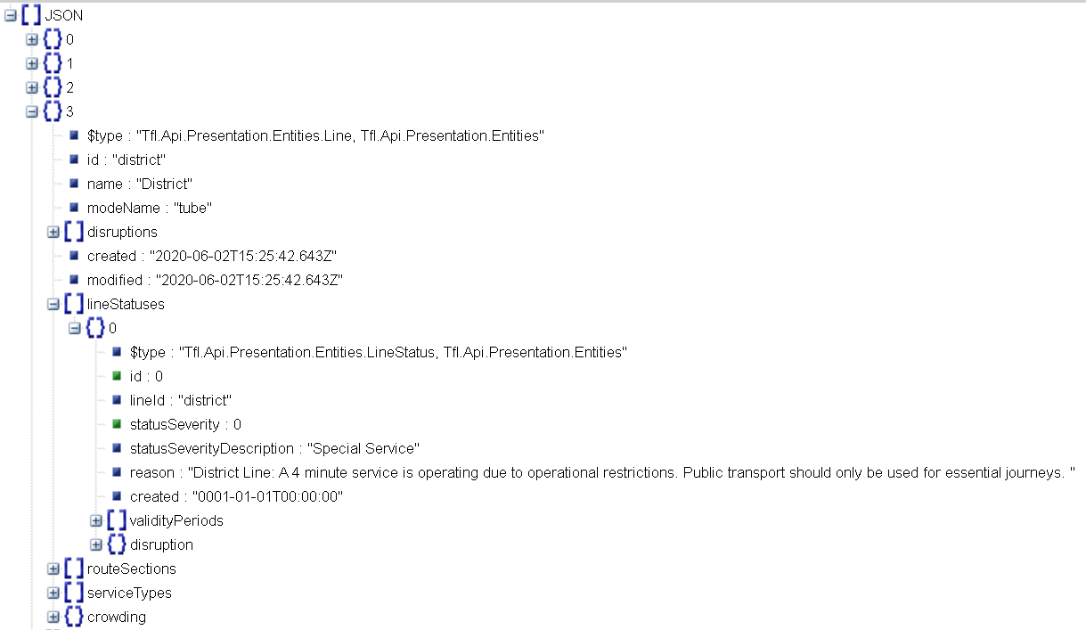
- Use Google to find a JSON formatter. Copy and paste the contents of the previous web request into a JSON formatter, and then examine the results. What do you think this JSON data is telling you?
- Create a web page which uses JQuery and AJAX to show the most relevant parts of the JSON data to the user:
  - You have seen examples of a button which fires an AJAX request. But in this case, it would be better if the AJAX request was fired as soon as the web page loads – the user shouldn’t have to take an extra step to initiate the action.
Therefore, inside the $(document).ready() function, you will need to add a call to $.getJSON()
  - Notice that the JSON contains an array. Therefore, you will need some kind of loop to go through each item in the array. An alternative would be to use $.each() to go through each item in the array.
  - For each item in the array, we are interested in its “name”.
  - Additionally, each item in the array contains a sub-array called “lineStatuses”.
We only need the first item from this sub-array – if there is more than one item in the array, you can just ignore everything except the first one.
From this first item, retrieve and display the “statusSeverityDescription”.
  - Ensure the data is displayed to the user in an appropriate format, so that the user can read it clearly!

For those who wish to have even more fun with APIs:
https://dragonball-api.com/api/characters?limit=4&page=1

